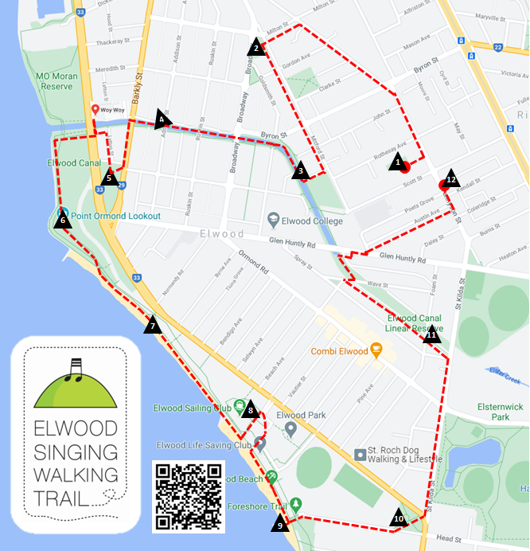

|  |  |
| --- | --- |
| Km | Song Site Location |
| 0.0 | 1. **Poets Garden** (87 Tennyson St, Rear of Elwood St Kilda Neighbourhood Learning Centre; Sign on north fence; ESNLC is the home of Elwood Community Choir. **Sing “We Honour the Land”**) |
| 0.9 | 1. **F.L. Dawkins Reserve** (Corner Broadway & Mitford St; Sign on park bench; Typical Elwood architecture. **Sing “Tumbalalaika”**) |
| 1.5 | 1. **Sundial beside Elwood Canal** (Near Keats St; Sign on park bench; Link to schools, local writer, old dance hall. **Sing “Carry On”**) |
| 2.0 | 1. **Elwood Sourdough Historic Site** (Canal path, near corner of Addison St; sign on park bench on canal path; Site of colourful and much-loved local bakery 2013-2025. **Sing “In Toast We Trust”**) |
| 2.3 | 1. **Robinson Reserve** (Between Barkly St & Marine Parade; sign on park bench; Early settlement history; Quarantine Station. **Sing “The Wark o’ the Weavers”**) |
| 3.1 | 1. **Point Ormond Hill** (Sign on park bench closest to top of hill; Views of Port Phillip Bay and Melbourne Skyline. **Sing “The Sea”** and **“The Southern Fiddler Ray’**) |
| 3.6 | 1. **Point Ormond Café** (Foreshore promenade; Sign on Beach Shack café; Great place to stop for coffee or ice cream. **Sing “La Mar Estaba Serena”**) |
| 4.1 | 1. **Picnic Area behind Elwood Sailing Club** (Sign on picnic table; Foreshore bushland; First Nations history. **Sing “Nerm”**) |
| 4.6 | 1. **Elwood Pier** (End of Head St; Sign near pier; Embedded tiles from 1999 arts and local history project. **Sing “Round the Cape”**) |
| 5.1 | 1. **Head St Reserve** (Beside Elwood Croquet Club, 1927; Sign on park bench; Pretty little park. **Sing “All About Elwood”**) |
| 5.8 | 1. **Elwood Canal Linear Reserve** (Foam St footbridge; Sign on footbridge railings; Lush, leafy canal walk. **Sing “The** **Rakali Hop”** and **“Kein Schöner Land in Dieser Zeit”**) |
| 6.8 | 1. **The King of Tonga bar** (164A Tennyson St; Sign at entrance; watering hole for Elwood Community Choir; **Sing** “**Elwood Song”** and **”King of Tonga Conga”**) |