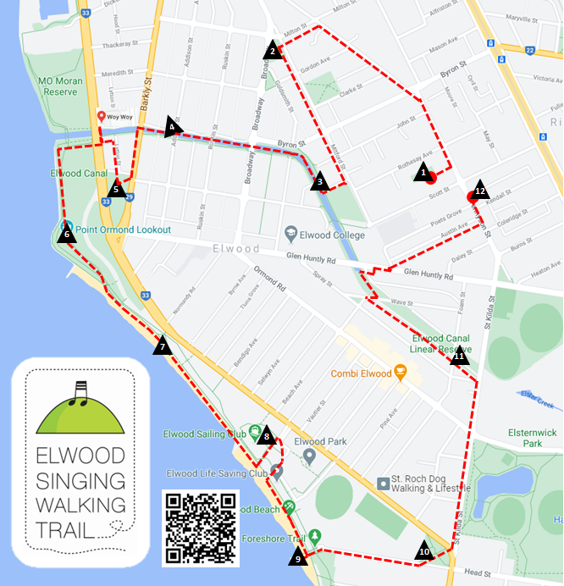

| **Km** | **Song Site Location** | **Walking Trail Route Instructions** |
| --- | --- | --- |
| 0.0 | 1. **Poets Garden** 87 Tennyson St, Rear of Elwood St Kilda Neighbourhood Learning Centre,   (ESNLC is the home of Elwood Community Choir) | **Find the first Song Site sign**.  **Sing “We Honour the Land”**  **Directions to Song Site 2:**   * **Return**toTennyson Street and **turn Left**. * **In 250m veer left** into Southey Street. * **In 400m turn left** into Milton Street. * **In 140m cross** Mitford Street to **enter the small reserve** on the corner of Broadway & Mitford St. |
| 0.9 | 1. **F.L. Dawkins Reserve**  Corner Broadway & Mitford St;   typical Elwood architecture | **Find the Song Site 2 sign** on the park bench closest to Broadway.  **Sing “Tumbalalaika”**  **Directions to Song Site 3:**   * From the Reserve, **continue** along Mitford Street. * **In 500m turn right** into Keats Street. * **In 40m turn right** to join the Elwood Canal path. |
| 1.5 | 1. **Sundial** **beside Elwood Canal**   Shape, circle  Description automatically generatedNear Keats St; link to schools, local writer, old dance hall | **Find the Song Site 3 sign** on the park bench near the sundial plinth.  **Sing “Carry On”**  **Directions to Song Site 4:**   * **Continue** along Elwood Canal Path toward the beach, crossing Broadway **in 200m**. **Continue** beside the canal. * **In 300m cross** Addison Streetand stop at 78 Addison Street. |
| 2.0 | 1. **Elwood Sourdough Historic Site** Canal path, near corner of Addison St; Site of colourful and much-loved local bakery 2013-2025 | **Find the Song Site 4 sign** on park bench on the canal path.  **Sing “In Toast We Trust”**  **Directions to Song Site 5:**   * **Continue along the canal path**. * **In 120 m cross** Barkly Street **and turn left** into Barkly Street. * **In 180m cross Shelley Street** to enter Robinson Reserve. |
| 2.3 | 1. Icon, circle     Description automatically generated with medium confidence**Robinson Reserve**  Between Barkly St & Marine Parade; Early settlement history;   Quarantine Station | **Find the Song Site 5 sign** on park bench in the middle of the reserve.  **Sing “The Wark o’ the Weavers”**  **Directions to Song Site 6:**   * **Return to cross** Shelly Street and **enter** Lytton Street. * **In 130m turn left** at the Elwood Canal. * **In 40m turn right** at Marine Parade, cross the canal and stop briefly to view the iconic Modernist *Woy Woy* apartments. * **Return back across the canal, then cross** Marine Parade at the pedestrian crossing. * **Follow the sealed walking path** straight ahead towards the beach. Take care crossing the cycle path at the bridge. * **In 300m turn left off the path**, carefully **cross the cycle path** and **climb up to the top** of Point Ormond Hill. Note: this steep hill may not be suitable for disabled access. The walking path has a gentler slope on the other side of the hill. |
| 3.1 | 1. **Point Ormond Hill**   Views of Port Phillip Bay and Melbourne skyline | **Find the Song Site 6 sign** on park bench closest to the top of the hill.  **Sing “The Sea”** and **“The Southern Fiddler Ray”**  **Directions to Song Site 7:**   * **Follow the walking path 150m** down towards the beach. Take care when crossing the bike path, to reach the **walking path** beside the beach. * **Follow the walking path for 250m** alongside the beach to reach **Point Ormond Café.** |
| 3.6 | 1. **Point Ormond Café** Foreshore promenade; great place to stop for coffee or ice cream | **Find the Song Site 7 sign** on the Beach Shack Café  **Sing “La Mar Estaba Serena”**  **Directions to Song Site 8:**   * **Continue along the beachside walking path**. * **In 400m turn left** after the **Elwood Sailing Club** and stop in the **picnic area.** |
| 4.1 | 1. **Picnic Area behind Elwood Sailing Club** Foreshore bushland; First Nations history | **Find the Song Site 8 sign** on the picnic table.  **Sing “Nerm”**  **Directions to Song Site 9:**   * **Return 50m** **to the beach**. * **Turn left** to follow the **beachside walking path** until you reach **Elwood Pier.** |
| 4.6 | 1. Icon     Description automatically generated**Elwood Pier**  End of Head St; embedded tiles from 1999 arts and local history project | **Find the Song Site 9 sign** on the pier wall.  **Sing “Round the Cape”**  **Directions to Song Site 10:**   * **Turn left (inland)** to walk along Head Street. * **In 400m** reach the **Elwood Croquet Club** in **Head Street Reserve.** * **Turn left to walk 100m** **diagonally through the reserve.** |
| 5.1 | 1. A picture containing shape     Description automatically generated**Head St Reserve**  Beside the Elwood Croquet Club, 1927; pretty little park | **Find the Song Site 10 sign** on the park bench, middle of the reserve.  **Sing “All About Elwood”**  **Directions to Song Site 11:**   * **Continue on** to cross Marine Parade at the lights to walk along   St Kilda Street.   * **In 600m** reach the Elwood Canal Linear Reserve. * **Turn left** (noting the Sir John Monash Bridge), then **continue 100m** further along the Canal Path **to** Foam St **pedestrian bridge.** |
| 5.8 | 1. **Elwood Canal Linear Reserve** Foam St footbridge; lush, leafy canal walk | **Find the Song Site 11 sign** on the footbridge railings.  **Sing “The Rakali Hop”** and **“Kein Schöner Land in Dieser Zeit”**  **Directions to Song Site 12:**   * **Return** to the Canal Path and **continue along it**. **In 350m cross** Wave Streetand **immediately turn right** onto the **pedestrian bridge to cross the canal.** * **Turn immediately left** along Paul Hester Walk.At Glenhuntly Road, **turn right and cross over at the pedestrian crossing**. * **In 50m turn left into** Mitford Street,then **immediately right into** Austin Avenue**. Continue 200m to cross** Tennyson Street**.** * **Turn left** to reach the Tennyson Street shops. |
| 6.8 | 1. **The King of Tonga Bar**  164A Tennyson St; Watering hole for Elwood Community Choir | **Find the Song Site 12 sign** at the entrance.  **Sing “Elwood Song**” and **“King of Tonga Conga”**  Finish at the **King of Tonga** for a drink, or coffee next door at the **bakery café**. |